Linux installation and basics

Filesystem:
Defi- is the method or structure used by OS to stored, retrieve and manage the data into the Disk.
Filesystem stored data in block format and give this block number indexing & each memory block by default size is 4KB.
indexing (Inode table)is to much Important fast to retrieve data from disk.
1GB = 1000MB
1GiB = 1024 MiB
Gigabyte -- gigibyte
meghabyte -- meghibyte
Note-when we attache 8 Gb pendrive to laptop . but in filesystem it show size less then 8GB. Cause we attache 8GB and computer convert this into GIB that’s the reason.
1 byte = 8 bit
1kb = 1024 byte
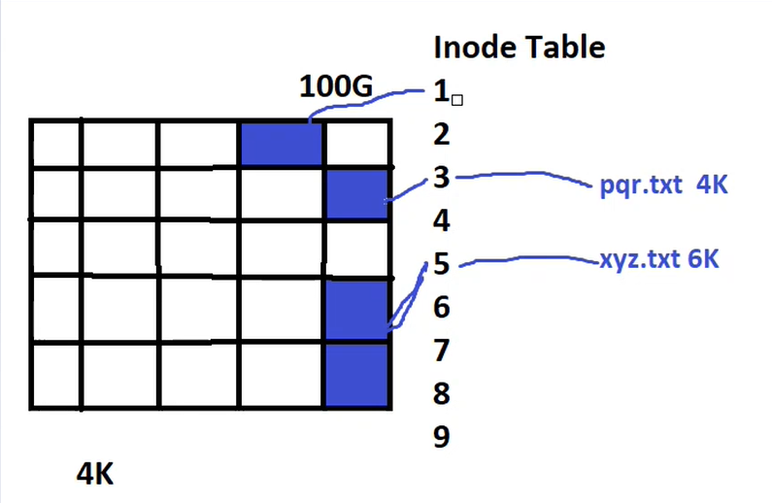
when we new install any file system or format filesystem then it automatically crate inode table or indexing table . and require around 1% size of filesystem.
when we create any .txt =4KB file then it assign the INode number and connect with memory block with them. like any is 6kb file then assign 1 inode and 2 block.
And suppose we delete this file just simply cut the connection from file and inode but data still on disk it not be deleted just override. And this can be recovered when we attach the inode to another file.
when we move data from one location to another take less time as compared to copy cause in move just break link and attach with new location of the node . but in copy data on disk In block also copy to another block on disk.
Boot Loder:
It’s small program that initialize or load the actual OS into the memory.
and it’s present in first sector or indixes of hard-drive. And this first sector called MBR(master boot record) and each sector is about 512 bytes.
So MBR is 512 bytes
512 bytes
IPL=initial program loader  446 bytes | Partition table  64 bytes | Boot signature  2 bytes

Boot loader present in MBR and MBR present in first sector and contain 512 bytes.
the partitioning schem
1)MBR create only 4 partition
2)GPT create 128 partition advanced version of MBR.

Bootloader : Used In
---------------------------
LILO : RHEL 3 and earlier (deprecated)
GRUB (Legacy) : RHEL 4, RHEL 5, RHEL 6
GRUB2 : RHEL 7, RHEL 8, RHEL 9, RHEL 10

Feature | Windows | Linux
Filesystem Layout | All data stored under a single drive (usually C:\) | Data organized into multiple directories (/home, /var, /boot, etc.)
Default Mount Point | Single partition (C: drive) | Multiple mount points (e.g. /, /home, /boot, /var, etc.)
Data Isolation | All data in one partition; failure affects entire system | Data split across partitions; failure may affect only part of the system
Security and Vulnerability Spread | A vulnerability can affect the whole partition, risking all data | Multiple partitions limit the spread of damage from vulnerabilities
System Resilience | Less resilient due to single point of failure | More resilient due to separation of concerns (OS, user data, boot files, etc.)
Linux architecture:
/ - master drive of linux system
/usr - installed software, stored binary
/var - stored variable data means that can be changes like logs
/boot - stored booting related data
/tmp – stored temoporary files
/home – stored user related data
/mnt - standard mount point
/dev – special devices files like hardware devices, kernel inetfaces.
Swap - virtual memory
Types of user:

- Super user (Administrator user)
- System user
- Normal user

✅ Section 2: CLI vs GUI

Feature | CLI (Command Line Interface) | GUI (Graphical User Interface)
User Interaction | Text commands | Visual elements like windows, buttons, icons
Ease of Use | Requires prior knowledge of commands | User-friendly and intuitive
Speed & Efficiency | Faster for experienced users | Slower due to manual navigation
Resource Usage | Very low (lightweight) | High (requires more CPU and RAM)
Automation & Scripting | Easily supports scripting and automation | Limited or no automation
Remote Access | Excellent (via SSH, etc.) | Requires remote desktop tools
Learning Curve | Steeper (requires memorizing commands) | Easier for beginners

Types of shells:

Feature | Bash (Bourne Again SHell) | Sh (Bourne Shell) | Csh (C Shell) | Zsh (Z Shell)
Popularity | Most common (default in Linux) | Very old, basic shell | Less common, older shell | Popular among developers
User-friendly | Yes | No (very minimal) | No (awkward syntax) | Yes (modern features)
Script Support | Strong scripting support | Basic scripting | Less used in scripts | Bash-compatible scripting

Absolute path and relative path
- Absolute path- those path which is start from /
Ex /root/workspace/ocp/auth
- relative path- those paths started from current directory.
Ex . workspace/ocp/auth

Soft Link and Hard Link:
Hard Link:
- same inode number just create multiple file link to this inode.
Main file is main.txt when create hardlink for multiple files like 1.txt, 2.txt it connct the same inode of main.txt
- if main.txt file size is 1 Gb and create multiple hard link then size not be increased it is same as 2 Gb
- when we any delete main.txt then it should be not affect the data of another files.
- When we make any changes in any link then it should be reflects in all files.
- You can create hard link between files not in directory.
- You can create hard link on same partition
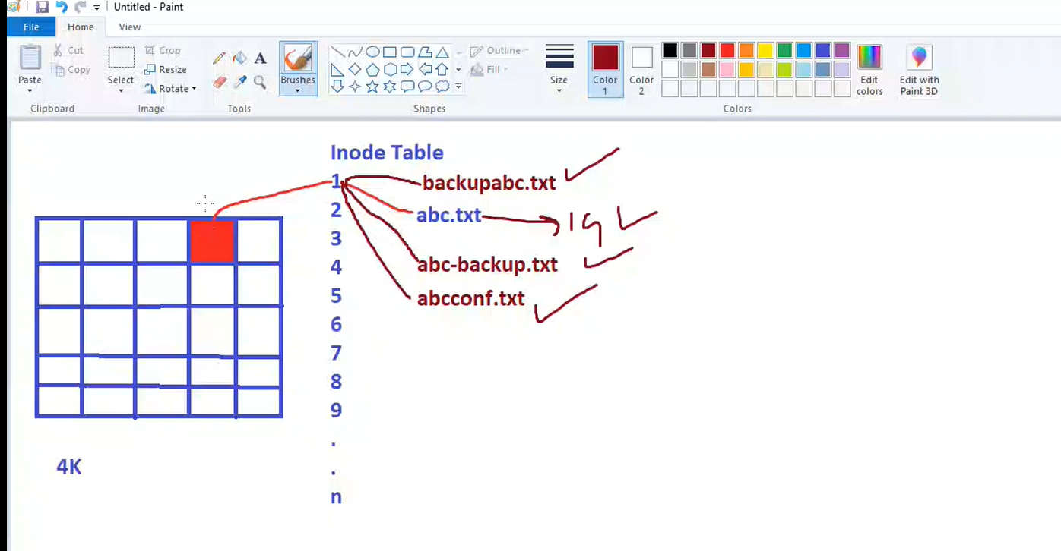

Soft Link (symbolic link): like shortcut in windows.
- Different inode number of both main file as well as soft link file
- When we add something in this file it should be reflects on soft link
- When we delete original files the data should be deleted on soft link
- We can done this on another partition also
- We can done this on file as well as directory

Symbols:
Input- stdin
Output – stdout
Error – stderr
> --- this symbol used to stored output in files. And we another time then it overwrite previous data deleted and add new data
Ex ls > list.txt
>> ---- this is used to append the file data previous data not deleted add new data to this file.
Ex ls >> list.txt

2> --- this is used to stoed only error not an output. and it overwrite
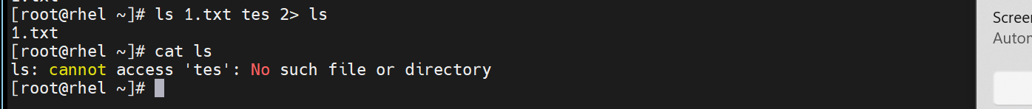
2>> --- this is used to stored error only. And it’s append the data

&> --- this is used to to stored output as well error . and it overwrite
&>> -- this is used to to stored output as well error . and it append data.
And we want to stored output and error on 2 seprate files use this combination
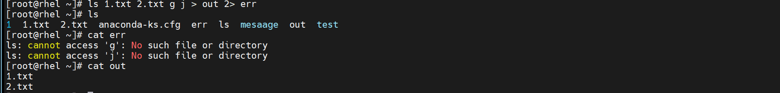

; -- want to excute multiple command on single line use this .
Ls ; mkdir test ; cd test ;touch pk

more - this command is used to see big file content by scrooling and if this file is scroll down can not be up .
less - this command is used see big file but we can scroll up and down.
head- this is used show top 10 lines
used -<number of lines>
ex head -n14 /etc/passwd
show above 14 lines
tail – this is used to show bottom 10 lines.

Pipe (|) – this command is used in first command output want to used in second command.
Ex want to check history command output in scrollable form
history | less
want to see 8th line of file without showing others file.
Head -8 sample.txt | tail -1
GREP:
for finding specific word from file
grep “test” file-name
for finding specific word from directory
grep -r “test” /root/workspace
Want to check line starting from root word
grep “^root” filename
Want to check line end from root word
grep “root$” filename
for ignoring the case (uppercase or lowercase)
grep -i “TEST” file-name
for check the which line number the word is present
grep -n “test” file-name
FIND:
Purpose: Search for files or directories based on name, type, size, modification time, etc
Find all .log files in a directory:
find /var/log -name *.log
find specific file in directory
find /var/log -name karan.log
Find directories only:
find /var/log/ -type d
find all files
find /var/log -type f
Find files larger than 1MB:
find /var/log -type f -size +1M
find file smaller than 1MB:
find /var/log -type f -size -1M
Find file between 50 MB to 100 MB
Find /var/log -type f -size +50M -size -100M
Find files modified in last 7 days:
find /var/log -type f -mtime -7
Find files in /home/karan/Documents older than 7 days:
find /home/karan/Documents -type f -mtime +7
Delete files older than 7 days
find /root/workspace/ -type f -mtime +7 -exec rm {} \;
Delete .log file which is older then 7 days.
find /root/workspace/ -type f -name *.json -mtime -7 -exec rm {} \;
Variables: variable is a symbolic name that holds a value — such as a string, number, or command output
Locale variable:
ENV variable:
lacale variable:
test=test this set the locale variable and we can see this echo $test locale variable only thi shell or terminal we close and open another one it does show this variable
env variable:
export TEST=test this variable should current shell as well for child process.
when we need make them permanent add in to the .bashrc file
in bashrc add export TEST=test and close and run this source ~/.bashrc
PATH variable:
PATH is an environment variable that tells the shell where to look for executable programs when you type a command.
2. How it works
- When you type a command like:
ls
- The shell searches each directory listed in $PATH in order until it finds the executable.
- If it doesn’t find it → you get command not found
set command used for setting locale variable
unset
export this command convert the shell variable into the env variable.

